Acute | Right | Obtuse
Straight | Reflex | Revolution
Complementary | Supplementary | Vertically Opposite
Perpendicular | 90$°$ | 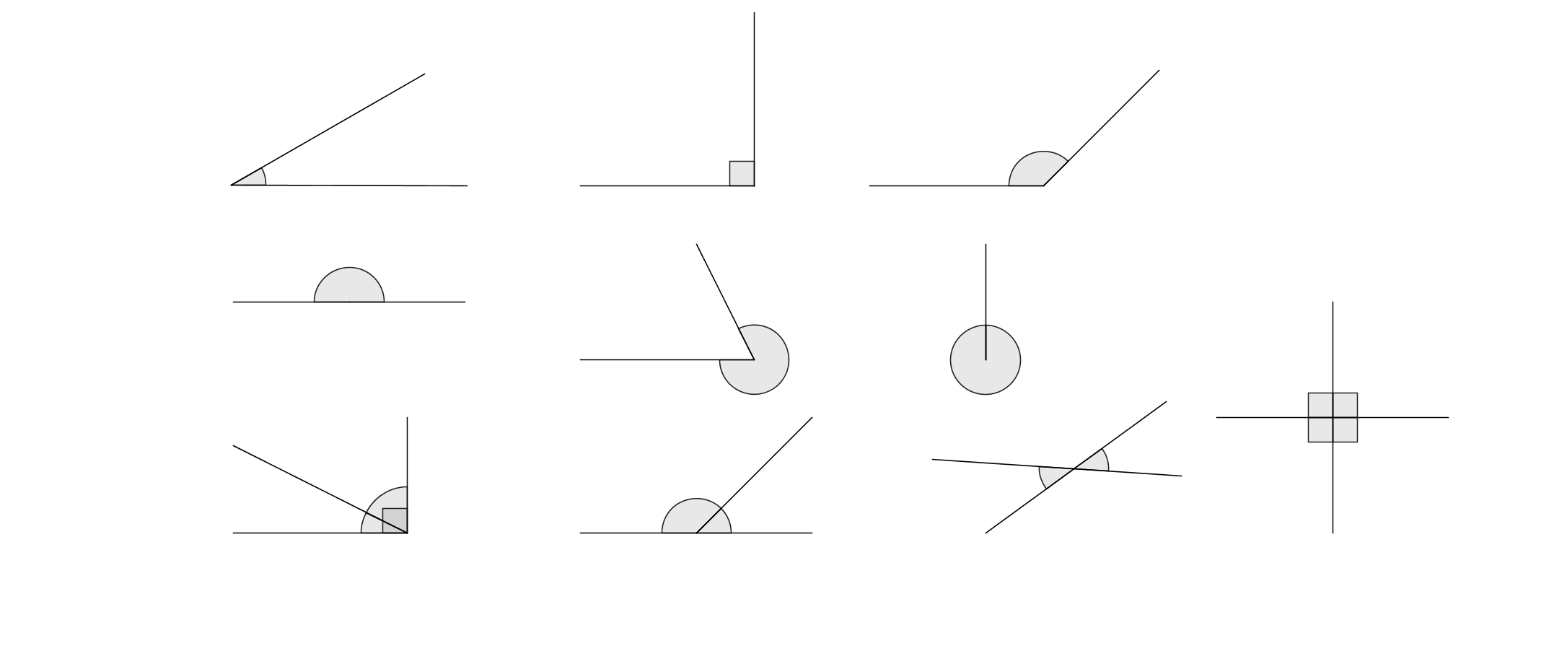
Between 90$°$ and 180$°$ | Sum to 90$°$ | 
 |  | Between 180$°$ and 360$°$
360$°$ |  | Intersect at right angles 90$°$
 | Between 0 and 90$°$ | 
Are equal |  | Sum to 180$°$
 |  | 180$°$

